1. Download all of the files in Aluminum Slumping/Codes/Smart Drill/roboclaw_python.
2. Add your csv file to the folder “roboclaw_python” that you download.
3. Open your computer’s Python editor. (Window computer/ Python version 3.7 and above)
4. Open the downloaded project in the Python editor and run the “roboclaw_interface” program.
5. A window like below should open:
6. 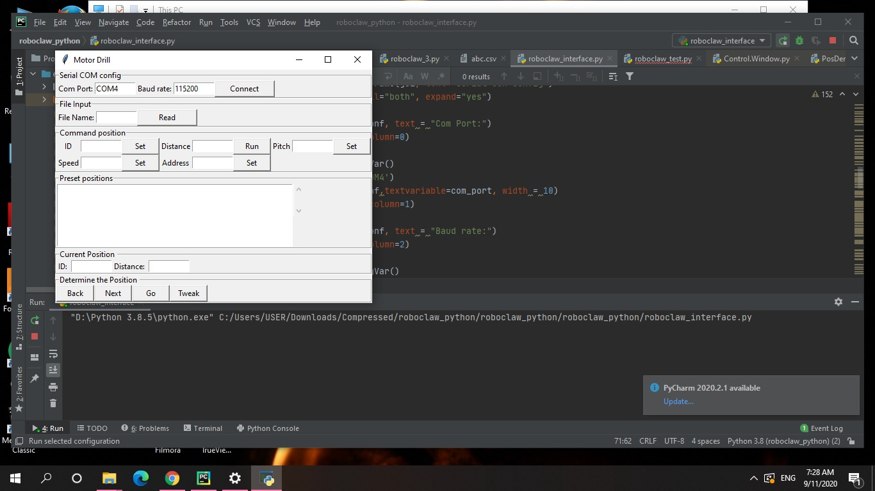
7. Enter the right com port. It should either be “COM1” or “COM2” or “COM3” or “COM4”, depending on your computer. An error should occur if it is an unidentified com port. Should an error occur and you do not know which com port it is, try one of the four mentioned above.
8. Enter the file name. For instance, “abc.csv” without the “”
9. The first-line ID and Distance would appear. Click “Back” or “Next” to go to your desired ID/Distance. Click “Go” to have the smart drill run. Click “Tweak” to tweak the smart drill.
10. You can also manually plug in your desired ID or Distance also.